Project Design Phase-II
Data Flow Diagram & User Stories

Date | 30 September 2026
Team ID | SWTID-2026-4985
Project Name | AI Fit track API
Maximum Marks | 4 Marks

Data Flow Diagrams:
FitSense Data Flow Diagram: The DFD shows how a user/client sends authentication, workout, search, and fitness information to the FitSense backend. The backend validates requests, manages user and workout data in MongoDB, and communicates with Google Gemini AI for personalized workout recommendations and fitness insights. The system returns structured JSON responses to the client.
Example: DFD Level 0 (Industry Standard)
FitSense DFD Level 0
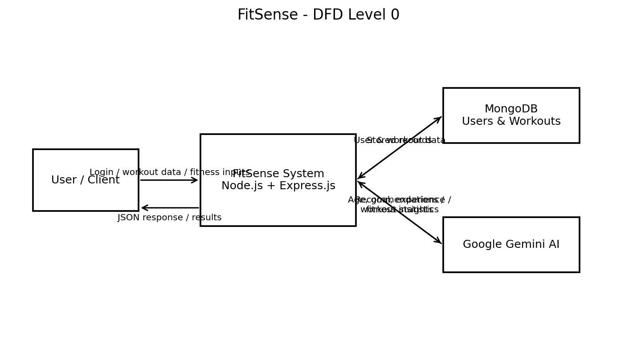
FitSense DFD Level 1
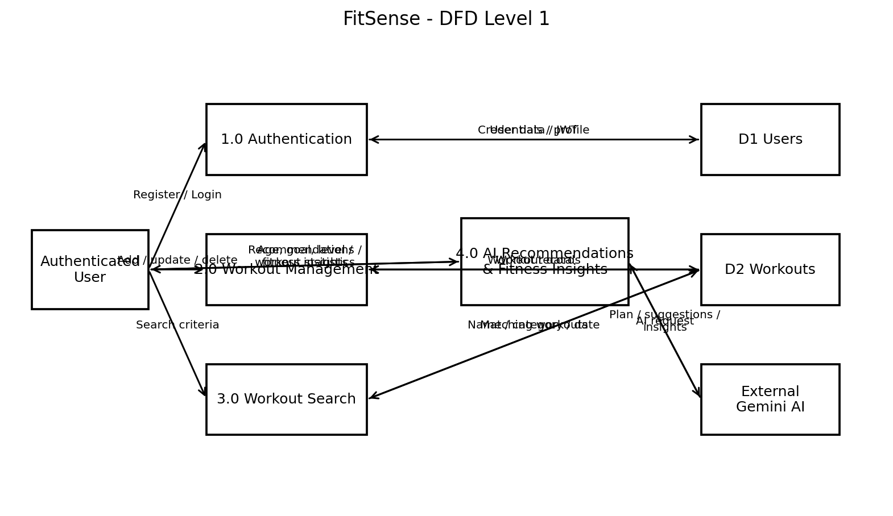
User Stories
Use the below template to list all the user stories for the product.
User Type | Functional Requirement (Epic) | User Story Number | User Story / Task | Acceptance criteria | Priority | Release
Authenticated User | Authentication | USN-1 | As a user, I can register an account using my name, email, and password. | A new user record is created; email is unique; password is stored securely using bcrypt. | High | Sprint-1
Authenticated User | Authentication | USN-2 | As a user, I can log in using my email and password. | Valid credentials return a JWT token and invalid credentials return an error. | High | Sprint-1
Authenticated User | Authentication | USN-3 | As a user, I can access protected APIs only after JWT authentication. | The JWT is validated and unauthorized requests are rejected. | High | Sprint-1
Authenticated User | Workout Management | USN-4 | As a user, I can add a workout record. | Workout name, category, duration, calories burned, and workout date are stored against the authenticated user. | High | Sprint-2
Authenticated User | Workout Management | USN-5 | As a user, I can view, update, and delete my workout records. | The user can retrieve, modify, or delete authorized workout records. | High | Sprint-2
Authenticated User | Workout Search | USN-6 | As a user, I can search my workouts by workout name, category, or workout date. | The API returns matching workout records from the user's workout history. | Medium | Sprint-2
Authenticated User | AI Recommendation | USN-7 | As a user, I can request a personalized workout recommendation using my age, fitness goal, and experience level. | Google Gemini returns a personalized workout plan, exercise suggestions, training guidance, and safety recommendations. | High | Sprint-3
Authenticated User | Fitness Insights | USN-8 | As a user, I can obtain AI-generated fitness insights from my workout statistics. | The system analyzes total workouts, average duration, and calories burned and returns performance insights. | High | Sprint-3
Authenticated User | Profile | USN-9 | As a user, I can retrieve my profile information after authentication. | The authenticated user's profile is returned through the profile API. | Medium | Sprint-1
Authenticated User | Error Handling | USN-10 | As a user, I receive meaningful responses when an API request fails. | The system returns appropriate JSON errors for invalid credentials, missing tokens, validation errors, database errors, and server errors. | Medium | Sprint-3

